**Mulesoft Certified Developer — Level 1: Questions & Answers — Quiz**

[[](https://sanket-m-kangle.medium.com/?source=post_page-----336e2751e01d--------------------------------)](https://sanket-m-kangle.medium.com/?source=post_page-----336e2751e01d--------------------------------)

[Sanket Kangle](https://sanket-m-kangle.medium.com/?source=post_page-----336e2751e01d--------------------------------)

·

[Follow](https://medium.com/m/signin?actionUrl=https%3A%2F%2Fmedium.com%2F_%2Fsubscribe%2Fuser%2F3708cdea6914&operation=register&redirect=https%3A%2F%2Fsanket-m-kangle.medium.com%2Fmulesoft-certified-developer-level-1-questions-answers-quiz-336e2751e01d&user=Sanket+Kangle&userId=3708cdea6914&source=post_page-3708cdea6914----336e2751e01d---------------------post_header-----------)

12 min read

·

May 27, 2021

48

1

1. What HTTP method in a RESTful web service is typically used to completely replace an existing resource?

* PUT

2. According to mulesoft, what is the center for enablement’s role in the new IT operating model?

* creates & manages discoverable assets to be consumed by the line of business developers.

3. What statement is part of Mulesoft’s description of an application network?

* Creates reusable APIs & assets designed to be consumed by other business units.

4. What mulesoft API led connectivity layer is intended to expose part of a backend database without a business logic?

* System

5. Refer to the exhibit. the API specification supports searching for articles on the searchworld.org site  
What is the most idiomatic(used for the intended purpose) URL method to retrieve articles about “einstein” in XML format?

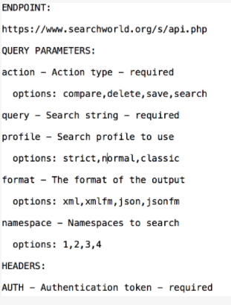

* Ans  
  http://www.searchworld.org/s/api.php?action=search&query=einstein&format=xml  
  AUTH : SK33DKD83829283JS

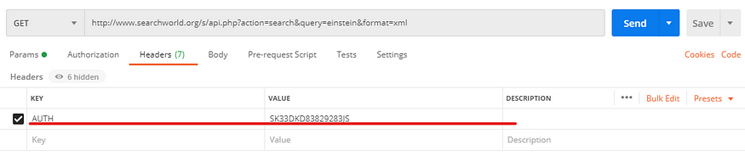

6. What is the core characteristic of modern API?

* API is designed first using an API specification for rapid feedback

7. What assets can NOT be created using the Design Center?

* API portals

8. What assets CAN be created using the Design Center?

* API specification
* Mule Applications
* Api Fragments

9. What Mulesoft product enables sharing & searching of APIs?

* API Exchange

10. Where does a deployed Flow Designer application run in anypoint platform?

* CloudHub Worker

11. What is the main purpose of Flow Designer in the Design Center?

* To design and develop fully functional Mule applications in a hosted development environment.

12. A web client submits a GET request to a Mule 4 application to the endpoint/customers?id=548, where is the id stored in the Mule event by HTTP Listener?

* Attributes

Following is a representation of the Mule event

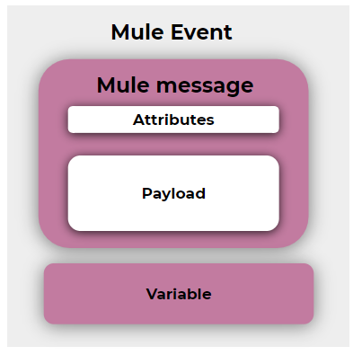

13. Refer to the exhibit. There is an error in the flight_id resource’s GET method. What needs to be done to fix the problem?

#%RAML 1.0  
version: v1  
title: American Flight API/flights:  
 get:  
 /{flight_id}:  
get:

* Intend the get method under the {flight_id} resource.

14. A RAML example fragment named BankAccountsExample.raml is placed in the examples folder in an API specification project. What is the correct syntax to reference the fragment?

examples: !include examples/BankAccountExample.raml

15. An API has been created in the Design Center. What is the next step to make the API discoverable?

* Publish the API to anypoint platform

16. Refer the exhibit. What is the correct URL to submit a GET request to /patients?

#%RAML 1.0  
title: ACME Medical API  
baseUri: <http://dev.acme.com/api>/patients:  
 get:  
 queryParameters:  
 year:  
 type: integer  
 example: 2017

* <http://dev.acme.com/api/patients?year=2016>

17. Refer to the exhibit. This RAML specification includes an XML example that matches the Record data type defined in another RAML file named recordsDataType.raml Using the Records type, how how can this XML be represented in RAML?

#%RAML 1.0  
title: Records API/records:  
 get:  
 responces:  
 200:  
 body:  
 application/xml:  
 example:  
 <music>  
 <colleection>Deep Collection</collection>  
 <artists>  
 <artist1>Deep purple</artist1>  
 <artist2>Rainbow</artist2>  
 </artists>  
 </music>

* Ans:

#%RAML 1.0  
title: Records API/records:  
 get:  
 responces:  
 200:  
 body:  
 application/xml:  
 type: Records  
 example:  
 music:  
 collection: "Deep Collection"  
 artists:  
 artist1: "Deep purple"  
 artist2: "Rainbow"

18. How does APIkit determine the number of flows to generate from a RAML specification?

* Creates a separate flow for each HTTP method

19. What is NOT part of Mule 4 event?

* inbound properties

20. What are part of Mule 4 event?

* message
* payload
* attributes

21. what is the purpose of the API:router element in APIkit?

* Validates requests against RAML API specifications & routes them to API implementation

22. What is the minimum required configuration in flow for a mule application to compile?

* An event processor

23. A database connector is configured to select rows from a MySQL database. What is the format of the array of results returned from the database query?

* Java

24. API manager has been configured to enforce an SLA policy and the RAML spec has been updated with the required client_id and client_secret header requirements.  
The new RAML spec has been published to anypoint exchange.  
What is the next step to gain the access of the API?

* Request access to the API in Anypoint Exchange

25. What does the Mule runtime use to enforce policies and limit acess to APIs?

* The Mule runtime’s embeded API gateway

26. What does an API proxy application NOT do?

* Determine which response Mule event is allowed to pass through to the API backend service

27. What does an API proxy application do?

* Determine which request Mule event is allowed to pass through the API backend service
* Apply runtime policies to enforce governance
* Meter the traffic flowing through the proxy

28. How many Mule applications can run on cloudhub worker?

* At most one

29. What is the purpose of API autodiscovery ?

* Allows a deployed Mule application to connect with API manager to download policies and act as its own API proxy

30. A mule application has a flow named parentFlow.  
The parentFlow contains an HTTP request operation at the end of the flow. The parentFlow also contains a Set Variable operation right before the HTTP Request operation.  
What is the scope of the variable to the server receiving the HTTP request from parentFlow?

* The variable is NOT accessible in the server.

31. A mule application has two flows named parentFlow and childFlow. The childFlow begins with an HTTP Listener. A variable is defined in parentFlow, then an HTTP request is made to childFlow’s HTTP Listener with some heeaders set. What is the scope of the variable and attributes in the parentFlow after childFlow returns a response?

* The variable is accessible. All the attributes passed to childFlow are removed or replaced.

32. What is NOT part of Mule 4 event?

* outboundProperties

33. Refer to the exhibit. What is the correct DataWeave expression for accessing the city Cleveland from JSON payload?

[  
 {  
 "orderID":592,  
 "shipping":"international",  
 "city":"Tokyo,  
 "price":5922345  
 },  
 {  
 "orderID":678,  
 "shipping":"domestic",  
 "city":"Cleveland,  
 "price":5123456  
 },  
 {  
 "orderID":253,  
 "shipping":"international",  
 "city":"Berlin,  
 "price":57654543  
 },

* #[payload[1].city]

34. A flow contains an HTTP listener as the event source. What is the DataWeave expression to log the content-type header using a logger component?

* #[“Content-Type: “ ++ attributes.headers.’content-type’]

35. A web service implements an API to handle requests to [http://acme.com/customers/{state}.](http://acme.com/customers/%7Bstate%7D.)

A web client makes a request to this API implementation at [http://acme.com/customers/](http://acme.com/customers/%7Bstate%7D.)CA

What is the correct DataWeave expression to retrieve the value CA?

* #[attributes.uriParams.state]

36. A Set Variable component saves the current payload to a variable with the name images. What is the DataWeave expression to access the images variable?

* #[vars.images]

37. What happens to the attributes of a Mule event in a flow after the outbound HTTP request is made?

* Attributes are replaced with the new attributes form HTTP request-response(which might be null)

38. What can ONLY be done with VM connectors, and not with Flow References in a single Mule application?

* Allow flow to pass events to another flow asynchronously

39. In what file does a Mule project keep track of all of its dependencies?

* pom.xml

40. Why must a Mule application’s deployable archive package all its dependencies in order to be deployed to CloudHub?

* CloudHub workers cannot download ALL possible project dependencies a project may contain

41. What reserved property can be defined and used in Mule application to allow an HTTP Listener to be accessed by external web clients after a Mule application is deployed to CloudHub?

* ${https.port}

42. Refer to exhibit. In the deployable archive’s/classes folder, there are two properties files named dev.properties and prod.properties deploy to CloudHub through Runtime Manager with the following error message

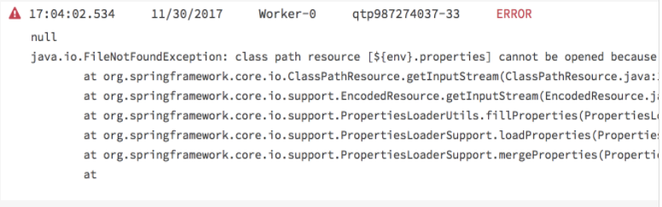

* The env property is NOT set in Runtime Manager in the Mule application’s properties tab

43. A Mule application has two flows named parentFlow and childFlow. A variable is defined in parentFlow. What is the scope of the variable when the parentFlow calls childFlow using Flow Reference?

* The variable can be accessed in childFlow, can be changed, and changes are seen back in parentFlow

44. What file type is required to configure a Web Service Consumer to consume a SOAP web service?

* WSDL

45. How are query parameters dynamically passed to an outbound REST requesting using an HTTP Request operation?

* As query parameters in the HTTP Request operation

46. Refer to the exhibit. The flow calls a SOAP endpoint using the Consume operation of the Web Service Consumer. The service has a required input parameter.

What event processor can be used to build the SOAP envelope with the required argument to pass to the SOAP service?

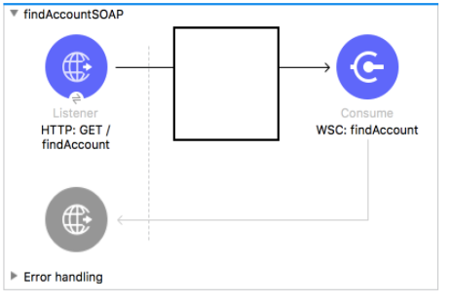

* Transform Message

47. An HTTP Request operation returns a JSON array of objects. In the Transform Message component, what is the process to convert the array of the objects to an array of custom JAVA Account objects?

* Add the account object metadata to the output and use the drag-and-drop feature to transform the incoming JSON data.

48. What is the process to create a connector using REST connect?

* Design the API in Design Center and publish the API to exchange.

49. How are multiple conditions used in a Choice router to route events?

* To find the FIRST true condition, then distribute the event to the ONE matched route

50. A Scatter-Gather processes three separate HTTP requests. Each request returns a Mule event with a JSON payload.

What is the final output of the Scatter-Gather?

* An object containing

51. An event contains a payload that is an array of objects how is the event routed in a Scatter-Gather?

* The ENTIRE event is sent to each route and processed in PARALLEL.

52. What module and operation will throw an error if a Mule event’s payload is not a number?

* Validation module’s Is Number operation

53. Refer to the exhibit. What happens to this flow when the Validation module’s Is not null operation throws an error?

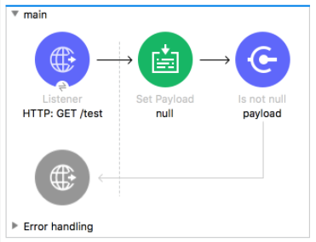

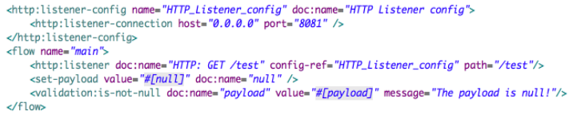

* The flow stops processing its Mule event and returns an error message to the HTTP Listener operation

54. Refer to the exhibit. The main flow has an On Error Continue scope with the type set to HTTP:NOT_FOUND. The Mule application configures globalErrorHandler as its default error handler.

A web client posts a request to the HTTP Listener. The transform message component then throws a MULE:EXPRESSION error trying to convert the payload to application/xml.

What response message is returned to the web client?

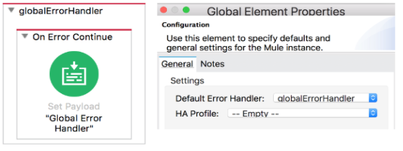

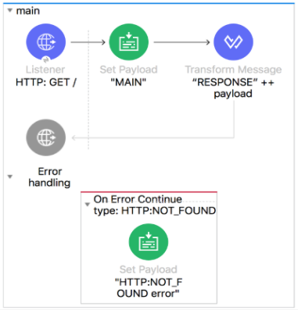

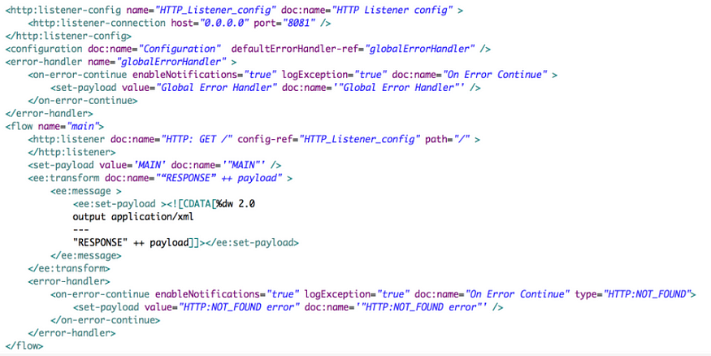

* The MULE:EXPRESSION error’s message

55. How can an error scope be configured to catch all errors in the HTTP namespace?

* Type:  
  When: #[error.errorType.namespace == “HTTP”]

56. Refer to the exhibit. The main flow has an On Error Continue scope and the private flow has an On Error Propagate scope.

A web client makes an HTTP GET request to the HTTP Listener. The Is number validator in the private flow then throws an error with message “validate — payload is an integer”

What response message is returned to the web client?

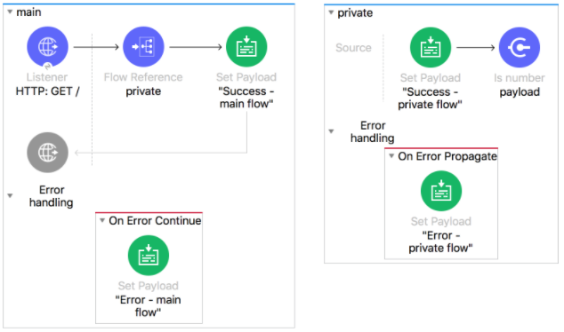

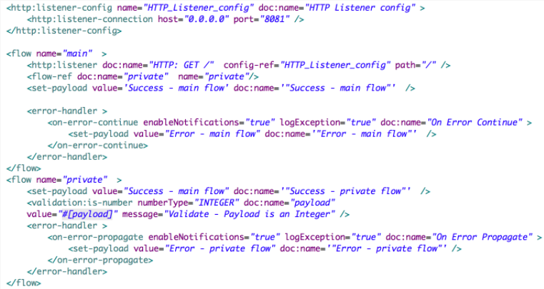

* Error — main flow

57. Refer to the exhibit. The private flow has On Error Propagate scope. The Mule application configures globalErrorHandler as its default error handler.

A web client makes an HTTP GET request to the HTTP Listener. The Is number validator in the private flow then throws an error with message “validate — payload is an integer”

What response message is returned to the web client?

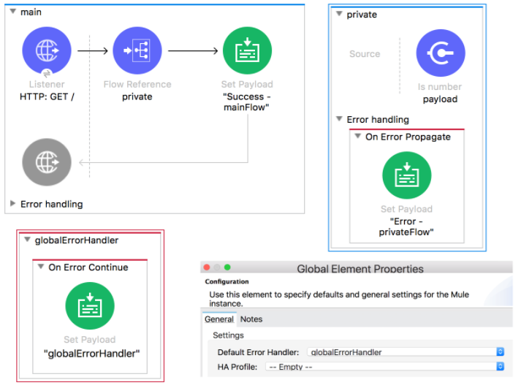

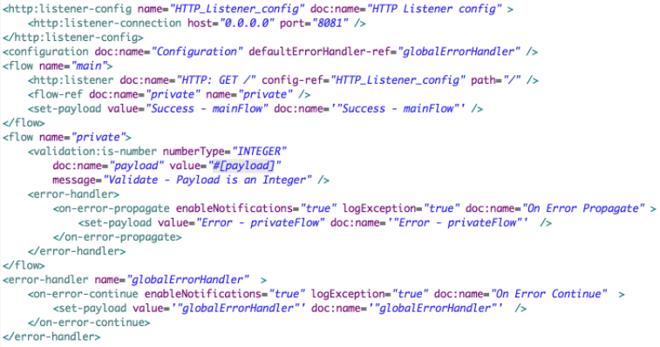

* globalErrorHandler

58. Refer to the exhibit. The main flow has an On Error Propagate scope. The Mule application configures globalErrorHandler as its default error handler.

A web client makes an HTTP GET request to the HTTP Listener. The Is number validator in the private flow then throws an error with message “validate — payload is an integer”

What response message is returned to the web client?

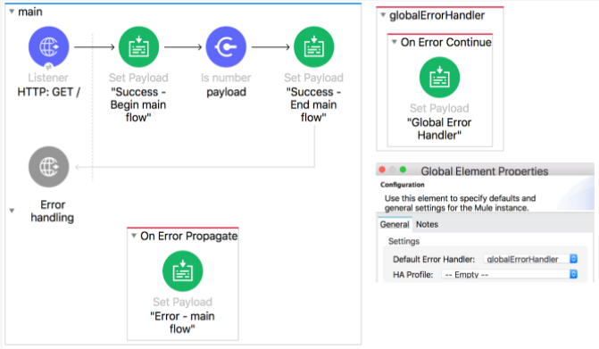

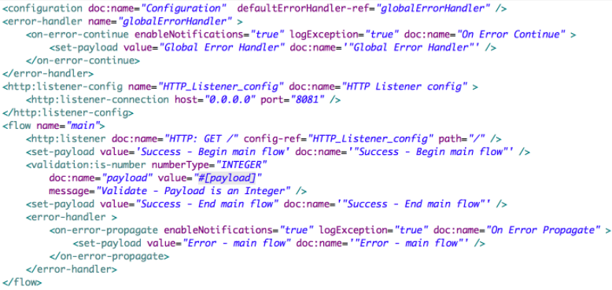

* validate — payload is an integer

59. Refer to the exhibit. The main flow has an On Error Continue scope. The Mule application configures globalErrorHandler as its default error handler.

A web client makes an HTTP GET request to the HTTP Listener. The Is number validator in the private flow then throws an error with message “validate — payload is an integer”

What response message is returned to the web client?

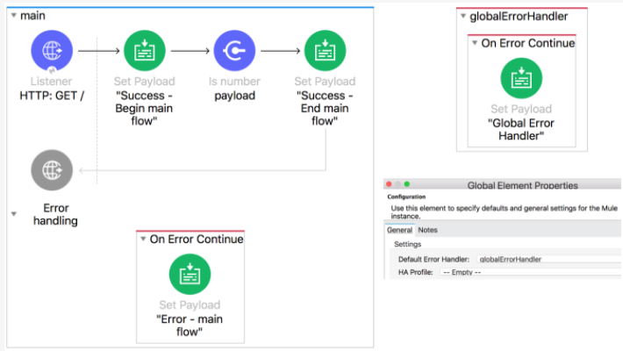

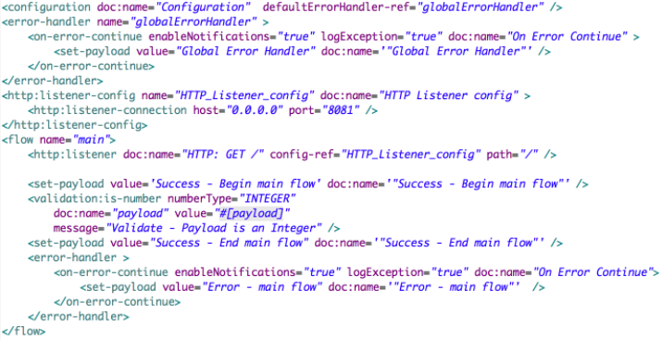

* Error — main flow

60. What is the correct way to format the decimal 20.3844 as a String to two decimal places?

* 20.3844 as String {format: “.0#”}

61. What DataWeave 2.0 type can be used as input to map operation?

* Array

62. A Mule application has a main flow and a combineNames flow. In the main flow, a variable named fullName is set to the object {firstName: “Max”, lastName: “Mule”}.

What is valid DataWeave code to call the combineNames flow with the input object stored in the fullName variable?

* #[lookup(“combineNames”, vars.fullName)]

63. Refer to the exhibit. What is valid DataWeave code to transform the input JSON payload to the output XML payload?

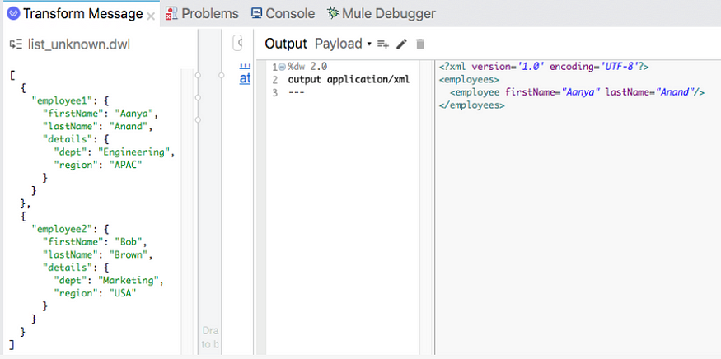

* ans:

%dw 2.0  
output application/xml  
---  
employees:  
 employee  
 @(  
 firstname: payload[0].employee1.firstname,  
 lastname: payload[0].employee1.lastname  
 ): null

64. Refer to the exhibit. An event payload contains an unordered array of flight objects, where every object has a price key and a toAirport key.

What is a valid DataWeave code to return flights with a price under 500, grouped by toAirport in ascending order, with the lowest price first?

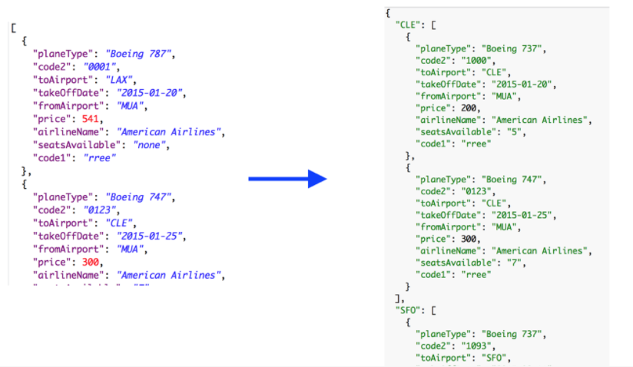

* ans:

payload filter $.price<500  
 orderBy $.price  
 groupBy $.toAirport

65. A flow reference component sends a non-empty JSON object payload to another flow named childFlow, which then returns an XML body.

A flow reference component saves the payload returned from childFlow to its target attributes named payload. Refer to the exhibit.

What is true about the Mule event’s payload at the next event processor after the Flow Reference component?

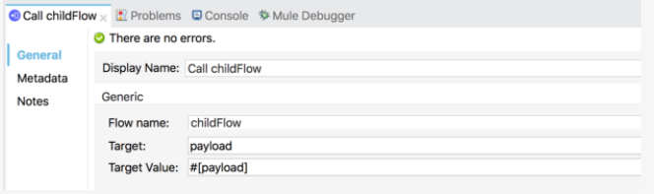

* The payload is original JSON object.

66. Refer to the exhibit. What is the object type returned by the File List operation?

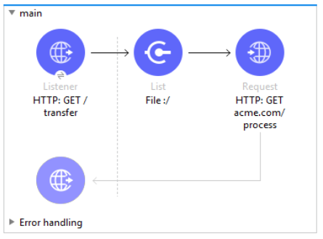

* Array of Mule event objects

67. In the database On Table Row operation, what does the Watermark column enables the On Table Row operation to do?

* To avoid duplicate processing of records in the database

68. Assume that a database table contains a recordID column that always increases as new records get added to the table.

In Mule application, what is the key process to enable manual watermarking for requests to a database using the Scheduler endpoint and the Database SELECT operation?

* Save the max recordID from the set of the recordIDs in an Object Store and reference this recordID in subsequent database request.

69. A flow has a JMS Publish Consume operation followed by a JMS Publish operation. Both of these operations have the default configurations.

Which operation is asynchronous and which one is synchronous?

* Publish Consume: Synchronous
* Publish: Asynchronous

70. Refer to the exhibit. What is the output of the Logger component in the Batch job?

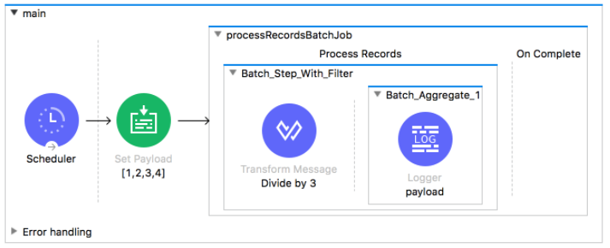

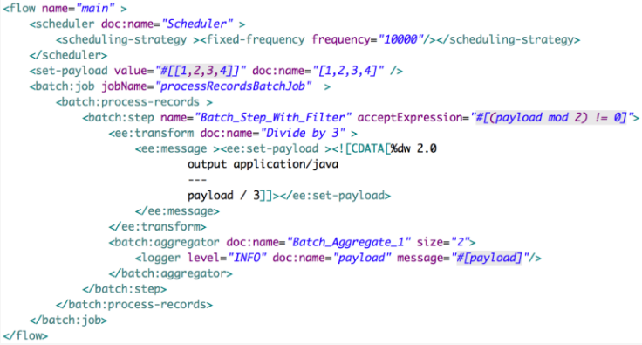

* Ans: [0.333, 1]

71. A batch job scope has three batch steps. An event processor in the second batch step throws an error because the input data is incomplete. What is the default behavior of the batch job after the error is thrown?

* All processing of the batch job stopos

72. Refer to the exhibit. What are the values of counter and stepVar variables after the Batch job?

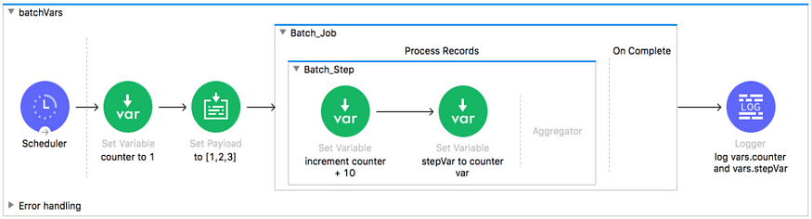

* counter: 1, stepVar: null

73. Refer to the exhibit. What are the values of counter and stepVar variables in the On complete phase?

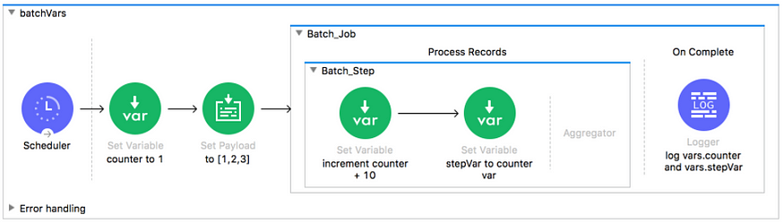

* counter: 1, stepVar: null

74. Refer to the exhibit. The payload [1,2,3] is passed to a batch job scope. In Batch_Step_1, a variable named batchStepPayload is set to the current payload. What is the value of the last log message after one batch job complete?

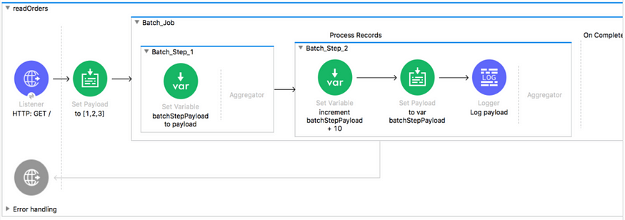

* ans: 13

75. Refer to the exhibit. The Set Payload component sets the payload to Map object (not an Array). The File Write operation writes out files based on this Map object. How many files are written to the file system when the flow executes?

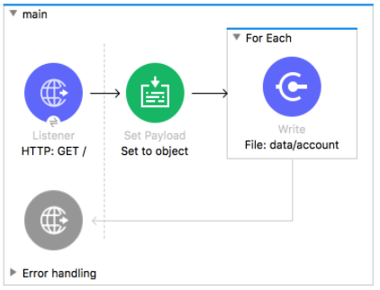

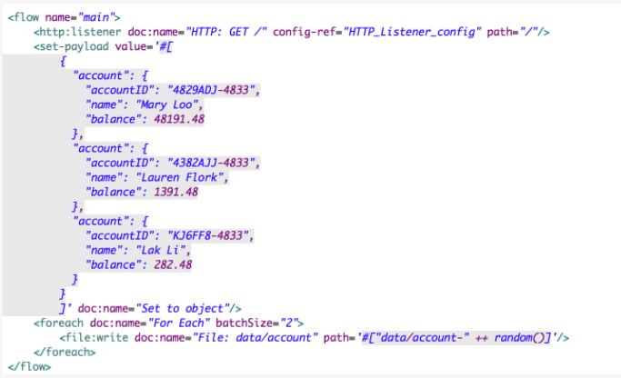

* Ans: 0